

Welland Centennial
Secondary School

2025-2026
Course Selections
D: ACADEMIC/DE-STREAMED, P: APPLIED, O: OPEN, E: WORKPLACE, M: MIXED, C: COLLEGE, U: UNIVERSITY
FRENCH IMMERSION COURSES ARE INDICATED BY (FI) IN COURSE NAME
DISCIPLINE | GRADE 10 |  |  | GRADE 11 |  |  | GRADE 12
 | COURSE |  | CODE | COURSE |  | CODE | COURSE |  | CODE
ARTS  Group 2 | Drama | O | ADA2O | Drama | M | ADA3M | Drama | M | ADA4M
 | Music: Guitar | O | AMG2O | Music: Guitar | M | AMG3M | Music: Guitar | M | AMG4M
 | Music: Instr. Beginner | O | AMI2O | Music: Instrumental | M | AMU3M | Music: Instrumental | M | AMU4M
 | Music: Instr. Experienced | O | AMU2O | Music: Vocal | M | AMV3M | Music: Vocal | M | AMV4M
 | Music: Vocal | O | AMV2O | Dance | M | ATC3M | Dance | M | ATC4M
 | Dance | O | ATC2O | Visual Arts | O | AVI3O | Visual Arts | E | AVI4E
 | Visual Arts | O | AVI2O | Visual Arts | M | AVI3M | Visual Arts | M | AVI4M
 | Visual Arts (FI) | O | AVI2OF | Photography: Visual Arts | M | AWQ3M | Photography: Visual Arts | M | AWQ4M
 |  |  |  | Media Arts: Yearbook Intro | M | ASM3M | Media Arts: Yearbook | M | ASM4M
BUSINESS  Group 2 | Launching/Leading Business | O | BEP2O | Financial Accounting | M | BAF3M | Accounting | M | BAT4M
 |  |  |  | Entrepreneurship | C | BDI3C | Business Leadership | M | BOH4M
 |  |  |  | Marketing | C | BMI3C
GEOGRAPHY  Group 1 |  |  |  | Physical Geography | M | CGF3M | Canadian and World Issues | U | CGW4U
 |  |  |  | Travel and Tourism | O | CGG3O
 |  |  |  | Travel and Tourism (FI) | O | CGG3OF
CANADIAN AND WORLD STUDIES  Group 1 for Gr.11 and 12 only | Canadian History | D | CHC2D | American History | U | CHA3U | World and Western History | C | CHY4C
 | Canadian History (FI) | D | CHC2DF | World History to 16th Century | M | CHW3M | World and Western History | U | CHY4U
 | Civics and Citizenship | O | CHV2O | Canadian Law | M | CLU3M | Canadian/International Law | U | CLN4U
 | Civics and Citizenship (FI) | O | CHV2OF
ENGLISH  Group 1 for EWC4C, EWC4U | English | D | ENG2D | English: Contemporary First  Nations, Métis and Inuit Voices | C | NBE3C | English  English  The Writer’s Craft  The Writer’s Craft  Interdisciplinary Studies | C  U  C  U  U | ENG4C  ENG4U  EWC4C  EWC4U  IDC4U
 |  |  |  | English: Contemporary First  Nations, Métis and Inuit Voices | U | NBE3U
GUIDANCE  Group 1 for GPP | Career Studies | O | GLC2OH | Peer Support (PAL) | O | GPP3O
 | Career Studies (FI) | O | GLC2OF
MODERNS  Group  1, 2, or 3  Italian is Group 1 only | French Immersion (FI) | D | FIF2D | French Immersion (FI) | O | FIF3O | French Immersion (FI) | O | FIF4O
 | Core French | D | FSF2D | French Immersion (FI) | U | FIF3U | French Immersion (FI) | U | FIF4U
 | Italian: Introduction | O | LWIBO | Core French | U | FSF3U | Core French | U | FSF4U
 |  |  |  | Italian | U | LWICU | Italian | U | LWIDU
HEALTH & PHYSICAL EDUCATION  Group 2 | Healthy Active Living | O | PPL2O | Healthy Active Living | O | PPL3O | Healthy Active Living | O | PPL4O
 | Healthy Living: Large Group | O | PAL2O | Healthy Living: Large Group | O | PAL3O | Fitness Activities: Female | O | PAF4OF
 | Fitness Activities: Female | O | PAF2OF | Fitness Activities: Female | O | PAF3OF | Fitness Activities: Male | O | PAF4OM
 |  |  |  | Fitness Activities: Male | O | PAF3OM | Recreation & Leadership | M | PLF4M
 |  |  |  | Health for Life | C | PPZ3C | Introductory Kinesiology | U | PSK4U
MATH | Foundations of Math | P | MFM2P | Math for Everyday Life | E | MEL3E | Math for Everyday Life | E | MEL4E
 | Principles of Math | D | MPM2D | Foundations for College Math | C | MBF3C | Foundations for College Math | C | MAP4C
 |  |  |  | Functions and Applications | M | MCF3M | Advanced Functions | U | MHF4U
 |  |  |  | Functions | U | MCR3U | Calculus and Vectors | U | MCV4U
 |  |  |  |  |  |  | Data Management | U | MDM4U
SCIENCE  Group 3 for Gr.11 and 12 only | Science | P | SNC2P | Biology | C | SBI3C | Biology | U | SBI4U
 | Science | D | SNC2D | Biology | U | SBI3U | Chemistry | C | SCH4C
 | Science (FI) | P | SNC2PF | Chemistry | U | SCH3U | Chemistry | U | SCH4U
 | Science (FI) | D | SNC2DF | Physics | U | SPH3U | Physics | C | SPH4C
 |  |  |  | Environmental Science | M | SVN3M | Physics | U | SPH4U
SOCIAL SCIENCES & HUMANITIES  Group 1 |  |  |  | Parenting | O | HPC3O | Working with Children | C | HPD4C
 |  |  |  | Working with Infants | C | HPW3C | Families in Canada | C | HHS4C
 |  |  |  | Anthro/Psych/Soc. | C | HSP3C | Families in Canada | U | HHS4U
 |  |  |  | Anthro/Psych/Soc. | U | HSP3U | Challenge & Change | U | HSB4U
 |  |  |  | Anthro/Psych/Soc. (FI) | U | HSP3UF | Challenge & Change (FI) | U | HSB4UF
TECHNOLOGY  Group 3 | Construction | O | TCJ2O | Construction | C | TCJ3C1 | Construction | C | TCJ4C1
 | Technological Design | O | TDJ2O | Technological Design | M | TDJ3M | Technological Design | M | TDJ4M
 | Computer Engineering | O | TEJ2O | Computer Engineering | M | TEJ3M | Computer Engineering | M | TEJ4M
 | Hospitality (Foods) | O | TFJ2O | Robotics and Control Systems | M | TER3M | Robotics and Control Systems | M | TER4M
 | Communication Technology | O | TGJ2O | Hospitality: Baking (1 credit) | E | TFB3E1 | Hospitality: Baking (1 credit) | E | TFB4E1
 |  |  |  | Hospitality: Baking (2 credit) | E | TFB3E4 | Hospitality: Baking (2 credit) | E | TFB4E4
 |  |  |  | Hospitality: Foods (1 credit) | C | TFJ3C1 | Hospitality: Foods (1 credit) | C | TFJ4C1
 |  |  |  | Hospitality: Foods (2 credit) | C | TFJ3C4 | Hospitality: Foods (2 credit) | C | TFJ4C4
 |  |  |  | New Media and Animation | M | TGI3M | New Media and Animation | M | TGI4M
 |  |  |  | Communication Technology | M | TGJ3M | Communication Technology | M | TGJ4M
 |  |  |  | TV, Video, Movie Production | M | TGV3M | TV, Video, Movie Production | M | TGV4M
 |  |  |  | Custom Woodworking | E | TWJ3E | Custom Woodworking | E | TWJ4E
CO-OP  Group 1, 2, or 3 |  |  |  | CO-OP (2 credit – half day) | O | COOP8 | CO-OP (2 credit – half day) | O | COOP8
 |  |  |  | CO-OP (4 credit – full day) | O | COOP9 | CO-OP (4 credit – full day) | O | COOP9
EASTDALE  Group 3 | This is a 2-credit grouping. Both courses must be taken. Transportation is provided between Centennial and Eastdale. |  |  | Auto Mechanics | C | TTJ3C | Auto Mechanics | C | TTJ4C
 |  |  |  | Welding | C | TMY3C | Welding | C | TMY4C

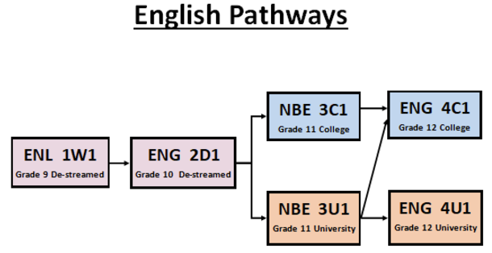
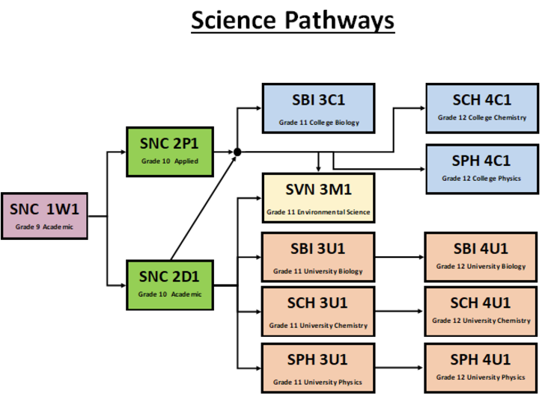
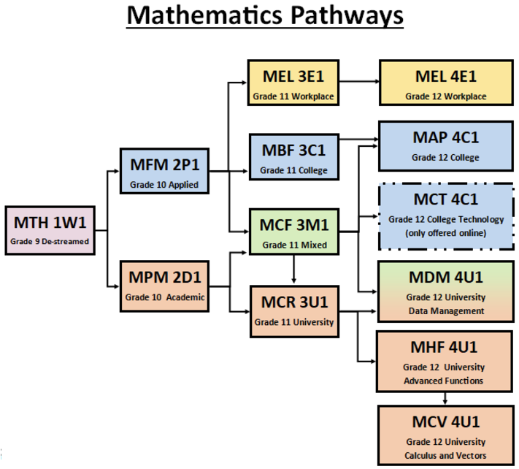
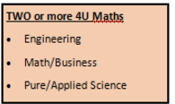
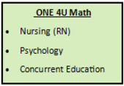
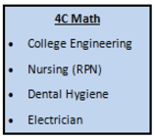
Post Secondary Tips:

Colleges will ONLY look at the final grade and not the stream, so students are encouraged to take the course where they can earn the highest grade

ALL Ontario College programs will accept ENG4U or ENG4C

ALL Ontario University programs will require ENG4U
Post Secondary Tips: Below are some sample post-secondary programs requiring different math courses.
Post Secondary Tips: Post Secondary programs requiring science usually require science ‘pairs’.
Biology & Chemistry: medical programs like nursing, dental hygiene, biochemistry, and medical sciences
Chemistry & Physics: university engineering

