

Welland Centennial
Secondary School

2025-2026
Course Selections
D: ACADEMIC/DE-STREAMED, P: APPLIED, O: OPEN, E: WORKPLACE, M: MIXED, C: COLLEGE, U: UNIVERSITY
FRENCH IMMERSION COURSES ARE INDICATED BY (FI) IN COURSE NAME
DISCIPLINE | GRADE 10 |  |  | GRADE 11 |  |  | Graduation Requirements
 | COURSE |  | CODE | COURSE |  | CODE | *New for 2028 Grads*
ARTS | Drama | O | ADA2O | Drama | M | ADA3M | Xello, our course planning software, is currently under construction and may not recognize your STEM course in the appropriate category. Do not worry! Guidance will resolve the issue for you.  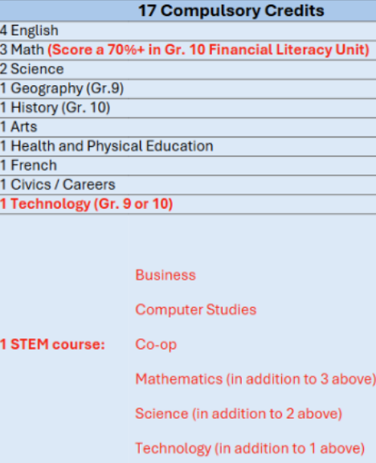  Courses which qualify as a  STEM graduation requirement are indicated in the discipline heading.  In addition to the 17 compulsory courses, students must complete 13 elective credits. These are courses of interest or courses that support their future pathway or plan.  Aside from compulsory and elective courses, students must also complete:  - 40 Community Involvement Hours  - Pass the Literacy Test  - 2 Online learning credits  (opt out option)
 | Music: Guitar | O | AMG2O | Music: Guitar | M | AMG3M
 | Music: Instr. Beginner | O | AMI2O | Music: Instrumental | M | AMU3M
 | Music: Instr. Experienced | O | AMU2O | Music: Vocal | M | AMV3M
 | Music: Vocal | O | AMV2O | Dance | M | ATC3M
 | Dance | O | ATC2O | Visual Arts | O | AVI3O
 | Visual Arts | O | AVI2O | Visual Arts | M | AVI3M
 | Visual Arts (FI) | O | AVI2OF | Photography: Visual Arts | M | AWQ3M
 |  |  |  | Media Arts: Yearbook Intro | M | ASM3M
BUSINESS  (STEM) | Launching/Leading Business | O | BEP2O | Financial Accounting | M | BAF3M
 |  |  |  | Entrepreneurship | C | BDI3C
 |  |  |  | Marketing | C | BMI3C
GEOGRAPHY |  |  |  | Physical Geography | M | CGF3M
 |  |  |  | Travel and Tourism | O | CGG3O
 |  |  |  | Travel and Tourism (FI) | O | CGG3OF
CANADIAN AND WORLD STUDIES | Canadian History | D | CHC2D | American History | U | CHA3U
 | Canadian History (FI) | D | CHC2DF | World History to 16th Century | M | CHW3M
 | Civics and Citizenship | O | CHV2O | Canadian Law | M | CLU3M
 | Civics and Citizenship (FI) | O | CHV2OF
ENGLISH | English | D | ENG2D | English: Contemporary First  Nations, Métis and Inuit Voices | C | NBE3C
 |  |  |  | English: Contemporary First  Nations, Métis and Inuit Voices | U | NBE3U
GUIDANCE | Career Studies | O | GLC2OH | Peer Support (PAL) | O | GPP3O
 | Career Studies (FI) | O | GLC2OF
MODERNS | French Immersion (FI) | D | FIF2D | French Immersion (FI) | O | FIF3O
 | Core French | D | FSF2D | French Immersion (FI) | U | FIF3U
 | Italian: Introduction | O | LWIBO | Core French | U | FSF3U
 |  |  |  | Italian | U | LWICU
HEALTH & PHYSICAL EDUCATION | Healthy Active Living | O | PPL2O | Healthy Active Living | O | PPL3O
 | Healthy Living: Large Group | O | PAL2O | Healthy Living: Large Group | O | PAL3O
 | Fitness Activities: Female | O | PAF2OF | Fitness Activities: Female | O | PAF3OF
 |  |  |  | Fitness Activities: Male | O | PAF3OM
 |  |  |  | Health for Life | C | PPZ3C
MATH  (STEM for Grade 12 Courses only) | Foundations of Math | P | MFM2P | Math for Everyday Life | E | MEL3E
 | Principles of Math | D | MPM2D | Foundations for College Math | C | MBF3C
 |  |  |  | Functions and Applications | M | MCF3M
 |  |  |  | Functions | U | MCR3U
SCIENCE  (STEM for Grade 11/12 Courses only) | Science | P | SNC2P | Biology | C | SBI3C
 | Science | D | SNC2D | Biology | U | SBI3U
 | Science (FI) | P | SNC2PF | Chemistry | U | SCH3U
 | Science (FI) | D | SNC2DF | Physics | U | SPH3U
 |  |  |  | Environmental Science | M | SVN3M
SOCIAL SCIENCES & HUMANITIES |  |  |  | Parenting | O | HPC3O
 |  |  |  | Working with Infants | C | HPW3C
 |  |  |  | Anthro/Psych/Soc. | C | HSP3C
 |  |  |  | Anthro/Psych/Soc. | U | HSP3U
 |  |  |  | Anthro/Psych/Soc. (FI) | U | HSP3UF
TECHNOLOGY  (STEM) | Construction | O | TCJ2O | Construction | C | TCJ3C1
 | Technological Design | O | TDJ2O | Technological Design | M | TDJ3M
 | Computer Engineering | O | TEJ2O | Computer Engineering | M | TEJ3M
 | Hospitality (Foods) | O | TFJ2O | Robotics and Control Systems | M | TER3M
 | Communication Technology | O | TGJ2O | Hospitality: Baking (1 credit) | E | TFB3E1
 |  |  |  | Hospitality: Baking (2 credit) | E | TFB3E4
 | If you did not take your Grade 9/10 Tech credit course in grade 9, then you must choose one of the above 5 courses to graduate. |  |  | Hospitality: Foods (1 credit) | C | TFJ3C1
 |  |  |  | Hospitality: Foods (2 credit) | C | TFJ3C4
 |  |  |  | New Media and Animation | M | TGI3M
 |  |  |  | Communication Technology | M | TGJ3M
 |  |  |  | TV, Video, Movie Production | M | TGV3M
 |  |  |  | Custom Woodworking | E | TWJ3E
CO-OP  (STEM) |  |  |  | CO-OP (2 credit – half day) | O | COOP8
 |  |  |  | CO-OP (4 credit – full day) | O | COOP9
EASTDALE | This is a 2-credit grouping. Both courses must be taken. Transportation is provided between Centennial and Eastdale. |  |  | Auto Mechanics | C | TTJ3C
 |  |  |  | Welding | C | TMY3C

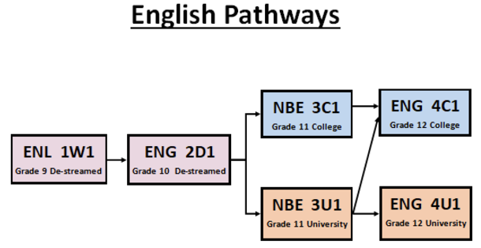
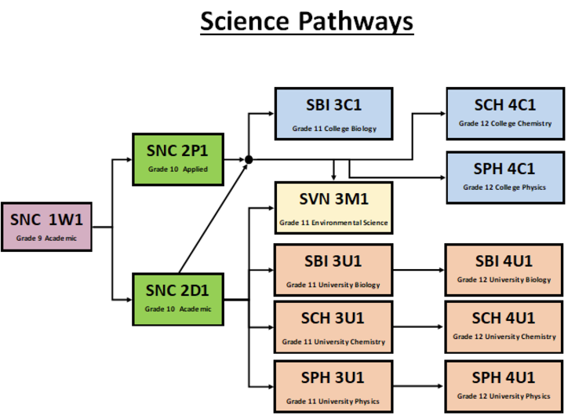
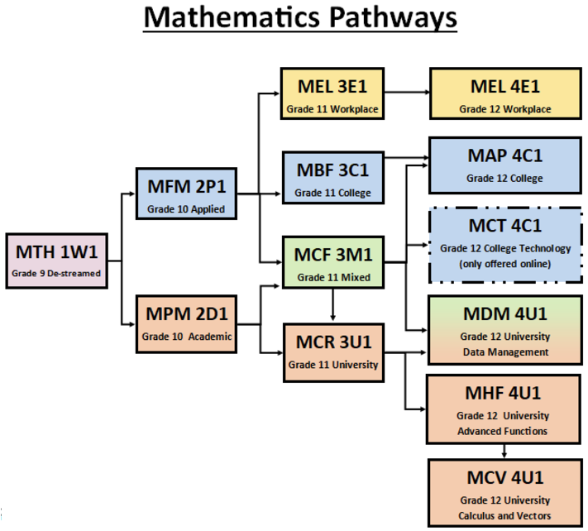
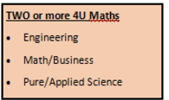
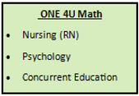
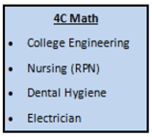
Post Secondary Tips:

Colleges will ONLY look at the final grade and not the stream, so students are encouraged to take the course where they can earn the highest grade

ALL Ontario College programs will accept ENG4U or ENG4C

ALL Ontario University programs will require ENG4U
Post Secondary Tips: Below are some sample post-secondary programs requiring different math courses.
Post Secondary Tips: Post Secondary programs requiring science usually require science ‘pairs’.
Biology & Chemistry: medical programs like nursing, dental hygiene, biochemistry, and medical sciences
Chemistry & Physics: university engineering

